- sit  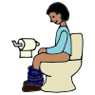  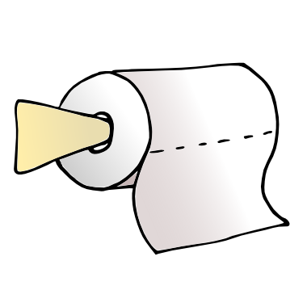  - wipe  - flush  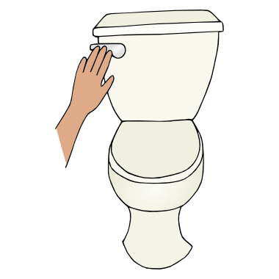  - wash  hands  Sing Happy Birthday 2 times | - sit  - wipe  - flush  - wash  hands  Sing ABC Song

- sit

- wipe

- flush

- wash
hands
Sing Happy Birthday
2 times

- wipe  - flush  - wash  hands  Sing Happy Birthday 2 times | - wipe  - flush  - wash  hands  Sing ABC Song

- wipe

- flush

- wash
hands
Sing Happy Birthday
2 times

- wipe

- flush

- wash
hands

Sing ABC Song

